Database Classwork

1. Write a query in SQL to find the name and the year of the movies.

Query

use movie;

select mov_title, mov_year

from movie;

Result

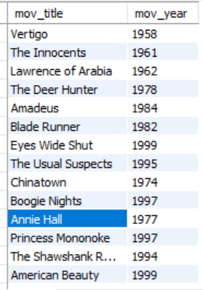

1. Write a query in SQL to find the year when the movie American Beauty was released

Query

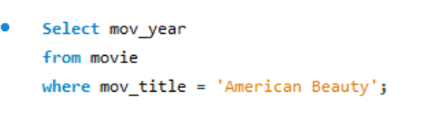

Result

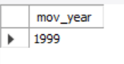

1. Write a query in SQL to which was released in the year 1999

Query

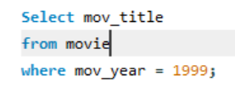

Result

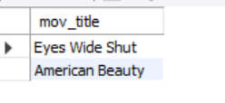

1. Write a query in SQL to find the movies which was released before 1998

Query

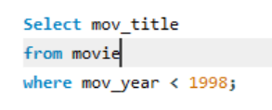

Result

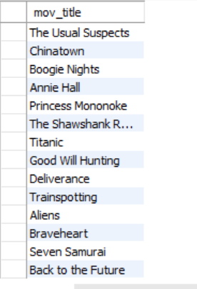

1. Write a query in SQL to return the name of all reviewers and name of movies together in a single list

Query

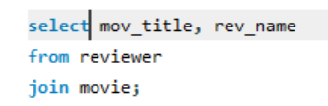

Result

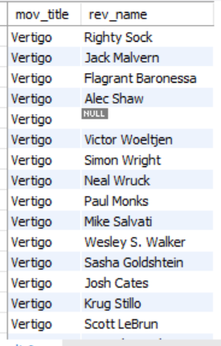

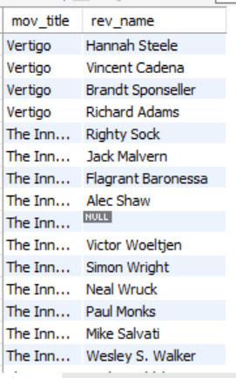

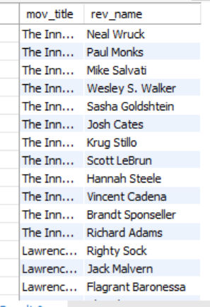

1. Write a query in SQL to find the name of all reviewers who have rated 7 or more stars to their rating

QUERY

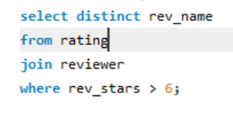

RESULT

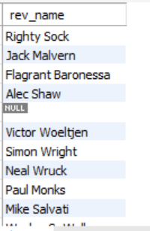

1. Write a query in SQL to find the titles of all movies that have no ratings

QUERY

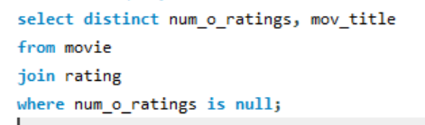

RESULT

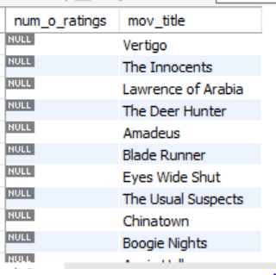

1. Write a query in SQL to find the name of all reviewers who have rated their ratings with a null value

QUERY

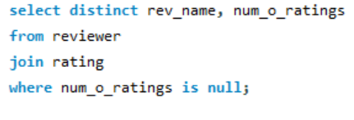

RESULT

